**Lab 2 – Implementing Algorithms**



1. Write an algorithm which draws a tree as illustrated in the diagrams below. Implement it in C.

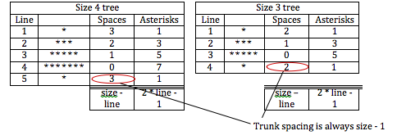

1. Develop an algorithm for rock paper scissors – this common game requires you and your opponent to produce one of 3 symbols at the same time – rock (closed fist), paper (palm open) or scissors (index and ring fingers). Think about how you might implement this project where the computer is the opponent. Use the Scratch project provided (**RockPaperScissors(start of).sb**) to implement your algorithm.

Please submit all lab code to the lab assignment in Brighspace.

1. Implement the Tower of Hanoi code – use the code to print out the list of moves for any number of disks. See if you can modify your code to print debug lines which would illustrate the call stack. Have a look at how to play the game here:-

<http://www.mathsisfun.com/games/towerofhanoi.html>

1. **Week 4 Quiz** 2 will open at 11.45 and close at 12.00. This will go towards your overall CA mark.